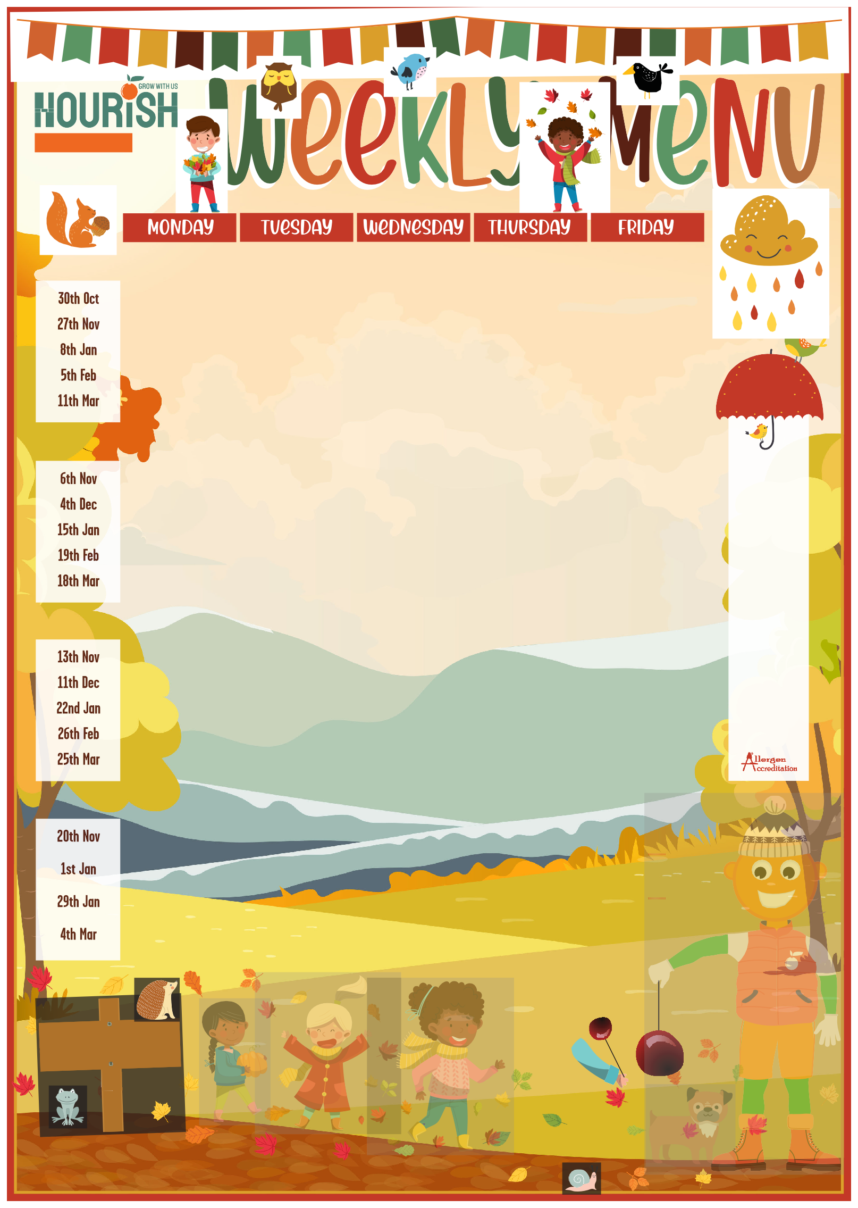
E
A
B
Y
E
L
0
E
2
C
G
N
I
T
S
A
R
R

Established 2003
OCT 23 TO MAR 24
 | Margherita Pizza 1,3,7,9  & Pasta 1 Jacket Potato Cheese or Beans 7  Seasonal Vegetables Salads, Bread 1,3,7,9  Iced Sponge 1,9  Mr Nourish Biscuit 1  Fruit Pots | Pork Sausages 1,6  Quorn Sausages 1 Jacket Potato Cheese or Beans 7  Mashed Potato Seasonal Vegetables Salads, Bread 1,3,7,9  Fruit Pots  Mr Nourish Biscuit 1  Yoghurt 7 | ROAST DAY -  Savoury Mince Beef & Dumpling 1 Jacket Potato Cheese or Beans 7  Roast Potatoes Seasonal Vegetables Salads, Bread 1,3,7,9  Fruit Pots  Mr Nourish Biscuit 1  Yoghurt 7 | Chicken Curry Vegetable Curry Jacket Potato Cheese or Beans 7  Rice, Salad, Bread 1,3,7,9  Jam Sponge 1,6,9  & Custard 7  Fruit Pots  Mr Nourish Biscuit 1 | Fish Fingers 1,8  & Chips Jacket Potato  Cheese/Beans/Tuna 7,8,9  Seasonal Vegetables Salads, Bread 1,3,7,9  Ice Cream 7  Fruit Pots  Mr Nourish Biscuit 1
 | Margherita Pizza 1,3,7,9  & Wedges Jacket Potato Cheese or Beans 7  Seasonal Vegetables Salads, Bread 1,3,7,9  Apple Crumble 1 & Custard 7  Fruit Pot  Mr Nourish Biscuit 1 | Pasta Bolognaise 1  Tuna Pasta 1,7,8 Jacket Potato Cheese or Beans 7  Seasonal Vegetables Salads, Bread 1,3,7,9  Fruit Pot  Mr Nourish Biscuit 1  Yoghurt 7 | ROAST DAY - Gammon & Gravy Jacket Potato  Cheese or Beans 7  Roast Potatoes Seasonal Vegetables Salads, Bread 1,3,7,9  Fruit Pot  Mr Nourish Biscuit 1  Yoghurt 7 | Jollof Rice with Chicken Jacket Potato Cheese or Beans 7  Seasonal Vegetables Salads, Bread 1,3,7,9  Jelly Fruit Pot  Mr Nourish Biscuit 1  Yoghurt 7 | Fish Fingers 1,8  or Salmon Fishcake 1,7,8  & Chips Jacket Potato  Cheese/Beans/Tuna 7,8,9  Seasonal Vegetables Salad, Bread 1,3,7,9  Chocolate Brownie 1,9  Fruit Pot  Mr Nourish Biscuit 1
 | Margherita Pizza 1,3,7,9  & Pasta 1 Jacket Potato Cheese or Beans 7  Seasonal Vegetables Salads, Bread 1,3,7,9  Lemon Sponge 1,9 & Custard 7  Fruit Pot  Mr Nourish Biscuit 1 | Chicken Pie 1  Vegetable Pie 1,7 Jacket Potato Cheese or Beans 7  Mashed Potato Seasonal Vegetables Salads, Bread 1,3,7,9  Fruit Pot  Mr Nourish Biscuit 1  Yoghurt 7 | ROAST DAY - Pork & Gravy Jacket Potato Cheese or Beans 7  Roast Potatoes Seasonal Vegetables Salads, Bread 1,3,7,9  Fruit Pot  Mr Nourish Biscuit 1  Yoghurt 7 | Sausage Roll & Savoury Rice Jacket Potato  Cheese or Beans 7  Savoury Rice Seasonal Vegetables Salads, Bread 1,3,7,9  Crispy Cake 7,16  Fruit Pot  Mr Nourish Biscuit 1  Yoghurt 7 | Fish Fingers 1,8  & Chips Jacket Potato  Cheese/Beans/Tuna 7,8,9  Seasonal Vegetables Salads, Bread 1,3,7,9  Ice Cream 7  Fruit Pot  Mr Nourish Biscuit 1
 | Margherita Pizza 1,3,7,9 & Savoury Rice Jacket Potato Cheese or Beans 7  Salad, Bread 1,3,7,9  Chocolate Cake 1,9  & Chocolate Sauce 7  Fruit Pot  Mr Nourish Biscuit 1 | Pasta Bolognaise 1  Tuna Pasta 1,7,8 Jacket Potato Cheese or Beans 7  Salad, Bread 1,3,7,9  Milkshake 7  Fruit Pot  Mr Nourish Biscuit 1 | ROAST DAY - Chicken & Gravy Jacket Potato  Cheese or Beans 7  Roast Potatoes Seasonal Vegetables Salads, Bread 1,3,7,9  Fruit Pot  Mr Nourish Biscuit 1  Yoghurt 7 | Mince Beef Pie 1 Vegetable Pie 1,7 Jacket Potato Cheese or Beans 7  Mashed Potato Seasonal Vegetables Salads, Bread 1,3,7,9  Jelly, Fruit Pot Mr Nourish Biscuit 1  Yoghurt 7 | Fish Fingers 1,8  & Chips Jacket Potato  Cheese/Beans/Tuna 7,8,9  Seasonal Vegetables Salads, Bread 1,3,7,9  Strawberry Mousse 7  Fruit Pot  Mr Nourish Biscuit 1

KEY: VG Vegan V Vegetarian
ST JOHN FISHER
LOOK OUT FOR
OUR THEMED DAYS!
Available Daily: Selection of Salads 9, Homemade Bread 1,3,7,9.
Some of our schools may use pre prepped potatoes or vegetables on occasions. These may contain sulphites and celeriac. Please discuss with your manager.

Dishes marked with any
of the following numbers contain the matching allergen:

- Wheat Gluten
- Crustaceans
- Soybean
- Mustard
- Sesame
- Sulphites/ Sulphur Dioxide
- Milk
- Fish
- Egg
- Peanuts
- Molluscs
- Celeriac/Celery
- Nuts
- Lupins
- Oat Gluten
- Barley Gluten

